**How to Request a Budget Adjustment in Fluxx for Departments**

***(Simplified and Updated process for 2025*)**

At the beginning of the Fiscal Year, or after a grant application is approved, departments are expected to set their budgets for the fiscal year based on their best estimation of what their expenses will be. However, as actual expenses come in throughout the fiscal year, departments may find it necessary to move funds between budget categories. This process explains how to move funds between budget categories and/or subcategories within a budget. Note: Funds cannot be moved between separate grants, meaning you can’t move money from State Aid to Local, or S&E to State Aid, etc. If you have any questions, please reach out to Caitlyn Porterfield or Kristin Hammock.

1. Open the Fluxx log in window on your computer.
   1. https://tjjd.fluxx.io/user_sessions/new
2. Log into Fluxx with your credentials.
   1. If you don’t have them yet, see the “How to apply for access to Fluxx” in your welcome email using form TJJD – AEU – 06-23-22 or contact IT directly.
3. On the left side of the screen, scroll down the dashboard (big grey bar on the left) to **APPROVED GRANTS.** Below that heading, there are several options.

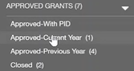

* 1. **Approved-With PID** refers to Reimbursement programs such as RDA and Detention Reimbursements, not Grants, which is explained in a separate tutorial.
  2. **Approved-Current Year** gives access to all of the current Fiscal Year Grants and Budgets.
  3. **Approved-Previous Ye**ar gives access to access to previous year’s Grants and Budgets that have not yet been closed out completely.
  4. **Closed** gives access to previous fiscal year’s Grants and Budgets that have been closed out, going back as far as FY 2023.

1. The option you click on will darken slightly, and a second lighter colored bar of Grants options will appear just to the right. Scroll though these options and choose the one you need to alter. Double check that the fiscal year and Grant name are correct before proceeding.
2. 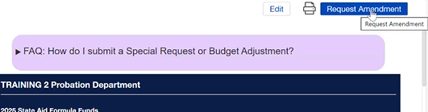Click **on the Amendment Requested button** on upper right corner of your screen. It is just passed the small print icon, in bright blue letters.
3. This will open a small window. Listing the options for Special request, and Budget Adjustment Request. Since a BAR is what we are after, click on the **Budget adjustment Request**. That will open the necessary Form.
4. At the top of the window, it should read, ‘Budget Adjustment Form’ with a dark blue box containing all the information about the grant. Verify that you have the correct grant open and then scroll down slightly until you see the words **BAR SUMMARY** at the upper left of the window.
5. Just below BAR SUMMARY is a question; ***What type of Budget changes are you requesting?*** To select one, or more, of the options in the box below the question on the left side of your screen, click on it, then click on the [ > ] button to move it to the rightmost box. You can choose one, or all the options, but you MUST choose at least one.
   * + 1. 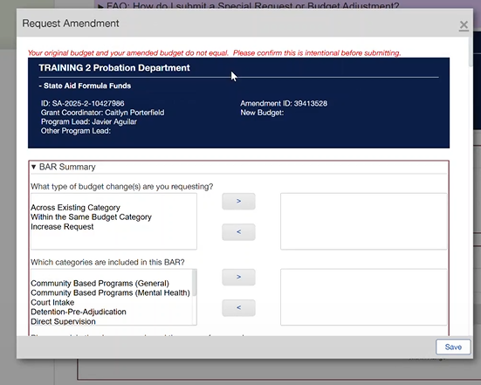 Choose ***“Across Existing Category”*** to move money from one category into another that already has money in it. This is selected when transferring money between budget categories. **Example**: Moving funds from Court Intake to Direct Supervision, budget categories that were both approved when the initial budget was approved.
   1. Choose ***“Within the Same Budget Category”*** to move money from one budget sub-category to another inside the same budget category. **Example:** Moving $5,000 from External Contracts to Internal Contracts in the Detention Pre-Adjudication budget category.
   2. Choose ***“Increase Request”*** to add money to a category without taking it from anywhere else. Typically, this label is only used for additional funds added to a budget and is never used for State Aid or any other situation, unless instructed otherwise.
6. Scroll down slightly until you reach the question ***“Which Categories are Involved in the This Bar”***. Just like above group of boxes choose one or more options. Clicking on those options will cause a dark gray highlight to appear. Use the light gray transfer button, that looks like this [ > ] in the center of the boxes, click it to move your selections to the rightmost box. Don’t worry if you make a mistake, you can use the second button in the stack, that looks like this [ < ] to move the erroneous selection back.
7. 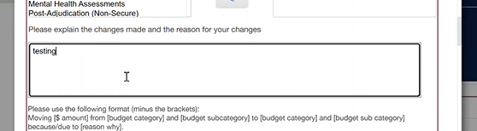**Explain the reason for the changes** – in this box, located just below the previous one, describe what is being done and why, using this format: ***Moving <$ amount> from <budget category and sub-category> to <budget category and sub-category> because/due to <reason why>.*** Please include all of the money movements in this box, repeating the format as many times as you need to. More information is better than less.
   1. **Example:** ***Moving $500 from Post Adjudication Secure Intercounty Contracts to Post Adjudication Non-Secure External Contracts due to change in expected detention costs.***
8. Now we enter the numbers; Scroll down, and you will see each of the categories you told us that you were editing, and all of their subcategories. Each of them will be filled automatically with the existing budget. Edit each of the ones you want to change so that they reflect what you want the budget to be now. Make sure to include all the additions and subtractions.   
   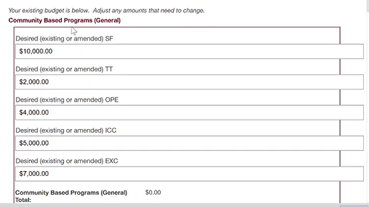
9. Do not Edit any of the fields that you do not want to change.
10. Check your numbers one more time. Make sure they reflect your wishes and that your explanation is full and complete. We can always fix mistakes, but it’s easier if we have the right information the first time.
11. Click **Save.**
12. If you want to keep a record of the BAR submitted, click the **Print** icon button on the upper right corner of the screen before moving on to the next step. You can also check your BAR history by clicking on
13. Click **Submit BAR** button on the bottom right corner. When clicked the button will turn a bright green. This sends the bar up for review. If you don’t want to send it for review yet, you can wait on this. Allowing others in your department to edit it, or check your work. But we cannot review it until it is submitted.
14. If you need to check and make sure that your request worked you can look for the Grant, if you did it right, the Grant will move from the Approved status to the Submitted Status.
15. If you have any problems or questions reach out to the Fiscal team, remember that we are on your side, and here to help you when you need it.

**Things to know**   
1. Please note BARS that have been saved but not submitted, can now be edited through Fluxx by departments. If a correction needs to be made, Move your curser to the dark gray bar on the left side of your Fluxx window. Scroll down below APPROVED GRANTS and look below the AMENDMENTS header. Click on Bars not submitted, choose the grant you wish to edit, click, and you will be able to adjust it.

2. Please note that you can only submit one budget adjustment for each grant at a time.

3. If your BAR needs edits before it can be approved, you will receive an email from the Fiscal Team, outlining what is needed.

4. Remember that you CANNOT submit Expenditures and Bars at the for the same Grant at the same time.

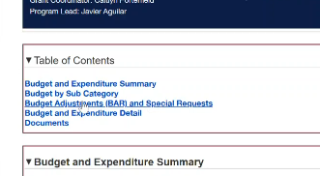5. You can view the history of your Grant’s Budget Adjustments by clicking on the correct sub-category under **Approved Grants** in the dark gray bar on the left of your screen. Choose the grant you wish to review from the lighter gray boxes slightly to the right of the dark gray bar by clicking on it. Once you do, the longer form of the grant will appear, filling the left side of the screen. Then, just below the dark blue box with the grant information in it you will see a box labeled **Table of Contents**. In this box the third option listed in blue is **Budget Adjustments (BAR) and Special Requests.**  Click on the option and then you can peruse all the edits that have been made to that grant.