**Expenditure Entry in Fluxx for Departments**

**Beginning Q2 of FY 2025**

After the end of every quarter, departments are expected to enter expenditures for expenses incurred and reimbursements received during the previous quarter, as well as account for any adjustments needed from previous quarters for that same fiscal year. This process explains how to enter those expenditures in Fluxx.

Note: Expenditure Entry periods are during the following time frames.

* Q1: 12/1 – 1/15
* Q3: 6/1 – 6/30
* Adjustment: 10/1 – 10/15
* Q2: 3/1 – 3/31
* Q4: 9/1 – 9/30

Expenditures cannot be entered by departments outside of these timeframes. After 10/15, if any additional adjustments need to be made, departments will need to request those changes directly from TJJD Fiscal Staff.

1. **Navigating to Expenditure Reports**
   1. During expenditure entry periods, log into Fluxx and navigate to the *Reports* section of the Dashboard.
   2. 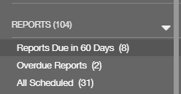Choose the *Reports Due within 60 Days* or *All Scheduled* link to see what reports are due.
   3. 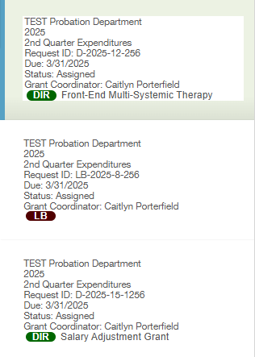Expenditure Report cards will be named as such.
   4. Choose the card for the grant/budget to enter expenditures in. The background of the card will change to a different color when selected and its information will populate on the right side of the screen.
      1. Note: Departments will not have access to previous quarter expenditure reports. Any missing expenditures or adjustments that need to be made should be done in the next open quarter.
2. **Report Breakdown**
   1. Red Banner – This lets departments know that the expenditures for that quarter have not been submitted and goes away once they are.
   2. Header – Provides basic information about the grant selected.
   3. FAQs (purple sections) provide information and guidance about the report. Review as necessary.
   4. Details for all Expenditure To-Date
      1. The first section called *View Expenditures by Quarter and Category (Read Only)* gives information about what expenditures have already been entered for that grant and updates as expenditure are submitted and approved. This is purely informational for departments but allows them to see what has been done without having to navigate to other sections in Fluxx.
      2. The second section called *Budget and Cumulative Expenditure Detail* is a table that lists the budget totals and expenditure totals by category and subcategory for that grant so departments can see, side by side, how much has been entered in relation to the budget submitted and any budget adjustment requests (BARS) that have been submitted to date. This can allow departments to stay on top of where BARS may be necessary.
      3. The third section called *Input Expenditures* shows only expenditures entered on the selected report and updates as departments enter their expenditures, save, and refresh the page to allow the formulas to update.
         1. Note: Local Budget looks different in that it includes that match requirements for the fiscal year and how much has been expended compared to the match requirement for both benchmark years. Reminder that departments are expected to meet their local match requirements unless there are extenuating circumstances which can be explained in a waiver within the Certification of Local Expenditures Report at the end of the fiscal year.
      4. The fourth section called Documents allows departments to upload necessary documents to the report, but should not often be necessary.   
         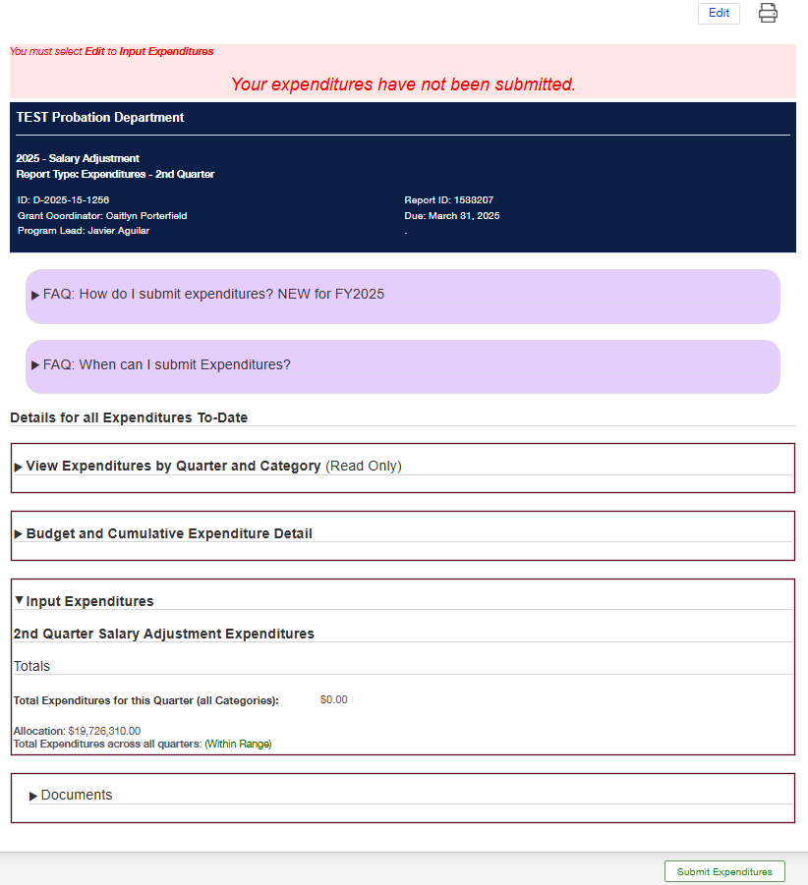
3. **Entering Expenditures**
   1. Click **Edit** at the top right corner of the screen.
   2. Departments will be able to open and close the items in section 2 above as needed for reference.
   3. 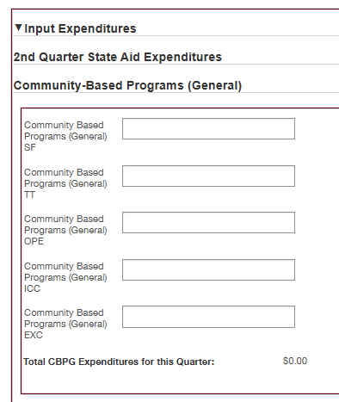In the section called *Input Expenditures*, each budget category and subcategory is listed, regardless of budget status and is available for departments to enter a dollar amount.
   4. NOTE: This form does not save automatically. Please click the **Save** button on the bottom right to save progress periodically.
   5. 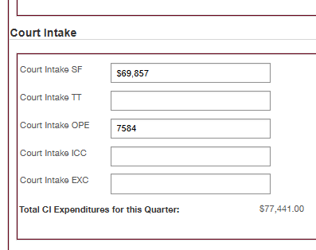Scroll through and enter expenditures per budget category and subcategory as needed until all expenditures for the quarter, as well as any adjustments, have been entered for that grant/budget.
   6. Each time the save button is clicked, the *Total Expenditures for this Quarter (all Categories)* section at the bottom will calculate the total, as will the *Total Expenditures across all quarters* section.  
      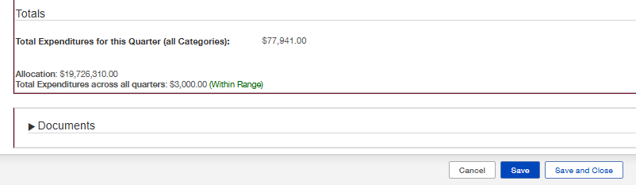
   7. Once expenditure entry is complete, click **Save and Close** to return to the Report Summary.
   8. The Input Expenditures section will update with the totals entered on this report and Budget and Cumulative Expenditure Detail section will update with the new totals entered into this report and add it to any previous expenditure reports submitted.   
      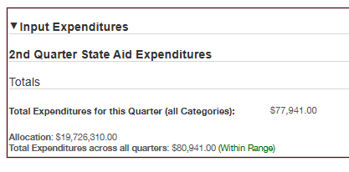
   9. Click **Submit Expenditures** on the bottom right corner of the screen to submit expenditures. Click **OK** when the confirmation pop up box appears. The status of the report will change from Assigned/Scheduled to Submitted and will be available in the Submitted link under Reports.
      1. Note: If the **Submit** button is not clicked, expenditures will not be submitted for review and approval by TJJD.
      2. Note: Departments are able to come back to this report in the Submitted section anytime during the expenditure entry period to make corrections. Simply follow steps 3.a through 3.h
   10. Continue with steps 3.a through 3.i for each Expenditure Report assigned (one for each grant/budget), even if there are no expenditures to enter. Submitting a report with zero expenditures is preferred over not submitting the report at all, so we know that you did not have expenditures, rather than assuming they were not entered.
   11. Departments may choose to print each expenditure entry period for each grant, which can be done by clicking the printer icon in the top right corner of the screen.
4. **Editing Submitted Reports**  
   Departments may need to make edits to current quarter expenditure submitted which may be done until the expenditure entry period closes.
   1. During expenditure entry periods, log into Fluxx and navigate to the *Reports* section of the Dashboard.
   2. Choose the *Submitted* link to see what reports have been submitted.
   3. Follow steps 3.a – 3.h until all corrections are complete.
   4. Note: The **Submit Expenditures** button will not be available when editing a submitted report, but simply a button with a period in it, which may be ignored. Clicking **Save and Close** is sufficient and editing expenditures can be done as often as necessary until the expenditure entry period closes. Once closed, the reports will be locked and all adjustments will need to be made in the next quarter.

Friendly reminder, Reimbursements from programs such as Regional Diversion Alternatives (RDA) and Detention Reimbursements run a month behind and are NOT considered revenue, but rather reduce expenditures and should credit the expenditure line the expenses came out of.

For example: If a department incurred $5,000 in detention costs for Q1 and credited those expenses to PAS EXC and then received reimbursement of $3,000 for those incurred costs in the same quarter, they would report $2,000 for Q1. If they received the reimbursement in Q2, they would subtract those reimbursements from their Q2 expenditures. Quarters 1 - 3 are reported on a cash basis.

EXCEPTIONS: Exceptions to the above guidelines would be:

* Q4 – Q4 expenditures are reported on an accrual basis, meaning that expenditures should be entered, taking into consideration any outstanding invoices they know are coming for expenses/services rendered on or prior to August 31st. Therefore, any known invoices, purchase orders, and assumed incoming reimbursements should be accounted for in the Q4 expenditure entry.
* Funds received not tied to a reimbursement program, such as Title IV-E and SB30 funding, should not be accounted for as reimbursements. These are rare.

If any questions arise, please contact the fiscal team (Caitlyn Porterfield and Kristin Hammock) via email and we would be happy to assist you.