**How to set reminders on tasks (with due dates) in Outlook?**

For example, many tasks have been assigned to you, which start at different times in one month. To follow up these tasks on time, you’d better set reminders on them. Here are some tricks about setting reminders on tasks (with due dates) in Microsoft Outlook.

**arrow blue right bubble****Set reminder on a task in Outlook**

You can set reminders for either new tasks or existing ones easily in Microsoft Outlook as following:

Step 1: Open a Task window:

1. Create a new task by clicking the **New Items** > **Task** on the **Home** tab in Outlook 2010 and 2013.
2. Create a new task by clicking the **File** > **New** > **Task**in Outlook 2007.
3. Open an existing task by double clicking it in the Task view.

Step 2: In the Task window, check the **Reminder** above the task body, and specify the reminder date and reminder time separately in the following boxes. See screen shot:

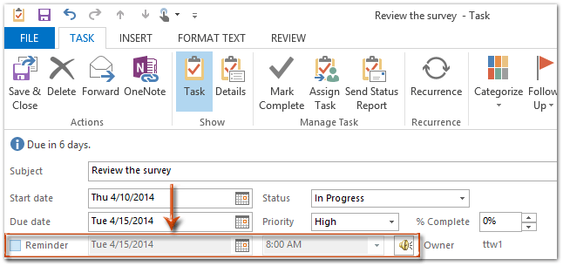

Step 3: Compose the task and click the **Save & Close** button.

**arrow blue right bubble****Set reminder on a task with Follow up feature in Outlook**

There is an alternative method to set reminder on a task with the Follow up feature.

Step 1: Open a Task window:

1. Create a new task by clicking the **New Items** > **Task** on the **Home** tab in Outlook 2010 and 2013.
2. Create a new task by clicking the **File** > **New** > **Task**in Outlook 2007.
3. Open an existing task by double clicking it in the Task view.

Step 2: In the Task window, click the **Follow Up** > **Add Reminder** in the **Tags** group on the **Task** tab (or **Options** group in Outlook 2007).

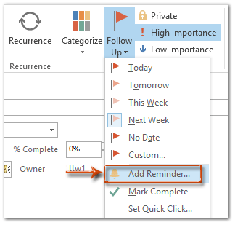

Step 3: In the Custom dialog box, check the **Reminder**, specify the reminder date and reminder time, and click the **OK** button.

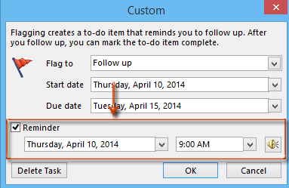

Step 4: Compose the task and click the **Save & Close** button.

Note: For an existing task, you can click to select it in the Task view, and click the **Custom** in the **Follow Up** group on the **Home**tab (or click the **Actions** > **Follow Up** > **Custom** in Outlook 2007) directly to open the Custom dialog box.

**arrow blue right bubble****Automatically set reminders on all tasks in Outlook 2010 and 2013**

The following trick will help you to automatically set reminders on all tasks with due dates easily in Microsoft Outlook 2010 and 2013.

Step 1: Click the **File** > **Options**.

Step 2: In the Outlook Options dialog box, click the **Tasks** in the left bar.

Step 3: Go to the **Task options** section, and check the option of **Set reminders on tasks with due dates**.

Step 4: Click the **Default reminder time:** box, and click to select a reminder time from the drop-down list.

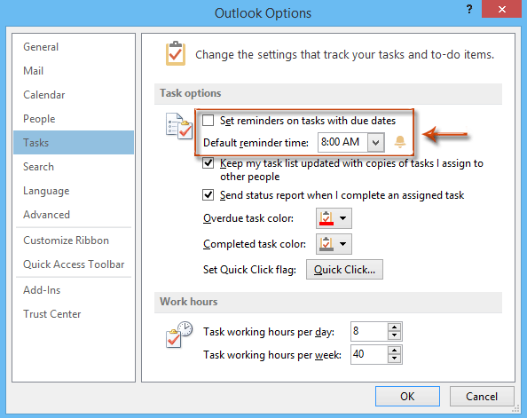

Step 5: Click the **OK** button.

From now on, when you are creating a new task in Outlook, the reminder will be added as soon as you specify the due date.

**arrow blue right bubble****Automatically set reminders on all tasks in Outlook 2007**

To automatically set reminders on all tasks with due dates in Microsoft Outlook 2007, please do as following:

Step 1: Click the **Tools** > **Options**.

Step 2: In the Options dialog box, click the **Task Options** button on the **Preference** tab.

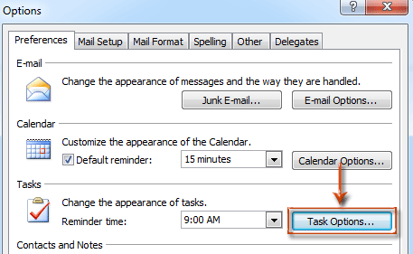

Step 3: In the Task Options dialog box, check the option of **Set reminders on tasks with due dates**, and click the **OK** button.

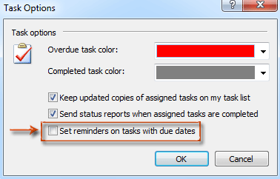

Step 4: In the Options dialog box, please click the **Reminder time:** box and specify a reminder time from the drop-down list in the **Tasks** section, and click the **OK**button.

After you enabling the reminder for tasks with due dates, the reminder will be added automatically when you are specifying a due date for a new task.

## How to Repeat Outlook Tasks

To repeat a task created in Microsoft Outlook:

1. Set a reminder for the first occurrence of the task.
2. Pick **Recurrence** from the **Task** tab.
3. Define the **Task Recurrence pattern,** such as the 1st day of the month or every Wednesday.
4. Choose OK and Save & Close to complete the task.

### **create Outlook task, repeating tasks in Microsoft Outlook, Outlook tips Why Reminders for Repeating Tasks Don’t Work**

When you create a recurring task with a reminder, you may notice the first reminder works, but it doesn’t repeat again for future tasks even when you enable the task recurrence. During an Outlook email productivity training session with an executive team, one of the participants shared that she no longer creates recurring tasks because the reminders stop working. The solution isn’t obvious due to a “flaw” in the display of reminders, but there is a way to continue seeing reminders for repeating tasks in Outlook.  Here’s the trick: **Don’t Dismiss Tasks!**

The design of Outlook’s Reminder window makes it easy to “break” recurring Tasks when you press the **Dismiss**button, which disables the reminder for the recurrence of the task. 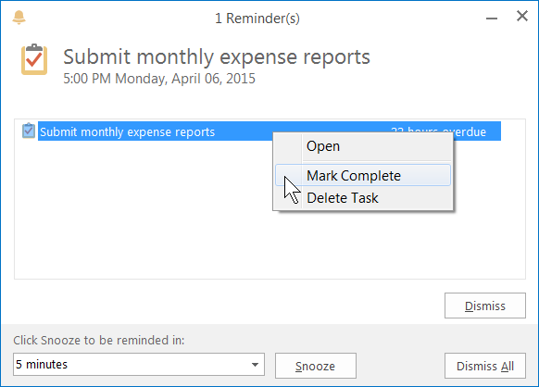You can still use Dismiss for repeating appointments, and the reminders will remain “attached” to future appointments.

To get the reminder for the task to repeat, you’ll first have to mark the previous task as completed. Outlook will then automatically create a new task based on your recurrence pattern.

To mark a task as complete, don’t pick **Dismiss** from the Outlook Reminder window. Instead, right-click on the task and choose **Mark Complete**. This would certainly be easier and more intuitive if the Reminder window had a Mark Complete button or even a more generic Actions button.

Tip: Tasks have a checklist icon at the front, while appointments have a mini calendar icon. You can still use **Dismiss** for appointment reminders.

### **How to Reset Reminders for Repeating Tasks**

To restore reminders for tasks you have already created, move to the Tasks folders from the button in the Mail/Navigation Pane or press **[Ctrl] + 4**. Select the recurring task and mark the recent occurrences with **Mark Complete** on the Ribbon or by right-clicking the task and choosing **Mark Complete**or by clicking the check box next to the task. You may also want to open the current task to make sure the Reminder option is still selected.

Save time and leverage the power of Outlook by creating tasks with repeating reminders.