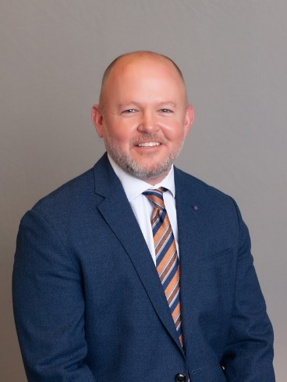

Matt Smith is the Director of Statewide Youth Services Continuum at the Texas Juvenile Justice Department. Matt is a Licensed Professional Counselor-Supervisor. He earned his bachelor’s degree in English & Psychology from the University of Texas at Austin in 1996 and his master’s degree in Human Services with a focus in Professional Counseling from St. Edward’s University in 2001. Matt began working in juvenile justice in 2001 as an Associate Psychologist with the Texas Youth Commission at Brownwood State School. He recently retired from Williamson County Juvenile Services Department after twenty-three years of service, having worked as a specialized juvenile probation officer (mental health and substance use), counselor, program supervisor, facility administrator, Director of Field Services, Director of Mental Health Services, and for the final fourteen years as Assistant Executive Director. Matt also served as the chair for the Williamson County Youth Behavioral Health Taskforce. Matt is a founding member of Resilient Wilco, a local initiative focused on educating the community about the impact of Adverse Childhood Experiences (ACEs). He is certified as an ACE Interface Master Trainer through UT Teen Health in San Antonio and a Level 1 & 2 Trauma-Informed Certification Trainer through Community Resilience Initiative. Matt previously served on the Georgetown Health Foundation Board of Directors. He previously served on the Dual Status Task Force of the Children’s Commission of the Texas Supreme Court. Matt has served as a Collaborative Council member of the Texas Judicial Commission on Mental Health and in January 2024 was appointed as a Commissioner.