
Stephanie R. Post
Supervisory Special Agent
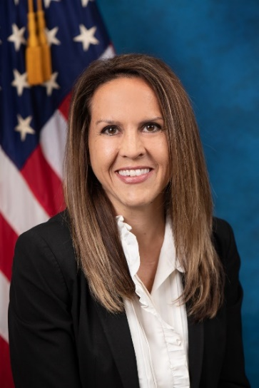 Stephanie R. Post entered on duty to the FBI as a Special Agent in 2008 and was first assigned to the Chicago Field Office and later assigned to the Des Moines RA, Puerto Rico, Little Rock and San Antonio Field Offices. SSA Post has worked violent gangs, public corruption, counterintelligence and terrorism matters. In 2018, SSA Post was selected for the Supervisory Special Agent position for the Joint Terrorism Task Force in Little Rock. SSA Post served in this role until she was selected for a Unit Chief position with the Domestic Terrorism Operations Section of the Counterterrorism Division at FBI Headquarters in September 2021. SSA Post then served as a Special Assistant to the Assistant Director of Security Division from April thru December 2023 when she transferred to San Antonio. SSA Post was selected to lead the Domestic Terrorism/Civil Rights and WMD squad in San Antonio in January 2025 where she currently serves.
SSA Post holds a Masters in Criminal Justice from Loyola University Chicago and an Undergraduate Degree in Sociology and Criminology from Kansas State University. Prior to joining the FBI, SSA Post worked as an analyst for the Kansas Bureau of Investigation assigned to the Midwest High Intensity Drug Trafficking Area (HIDTA) in Kansas City, MO.
SSA Post is married to Ben Post, an Assistant Special Agent in Charge of the San Antonio Office of the Drug Enforcement Administration and is the proud Mom of Elijah (5) and Jeremiah (1).

