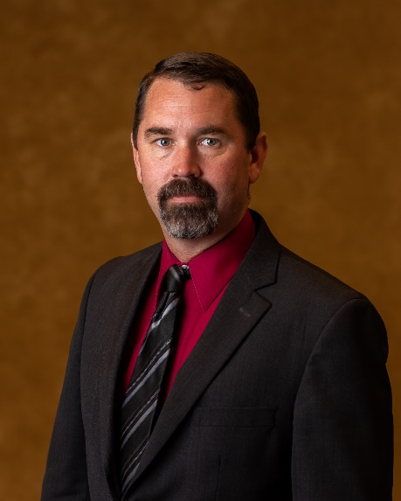
Marshall Davidson Biography
Special Investigations Regional Director

Marshall Davidson is a Special Investigations Regional Director with the Department of Family and Protective Services (DFPS). He is a Master Peace Officer with over 21 years of law enforcement experience, a TCOLE instructor and he currently holds a reserve license with the Zapata County Sheriff's Office. He has 15 years working with the DFPS and has worked and supervised thousands of cases involving abuse and neglect. These cases involve the most extreme cases of abuse such as child deaths, sex and labor trafficking, and severe physical and sexual abuse. Marshall has supervised just over 250 Special Investigators and 26 Program Directors across Texas. He currently supervises 4 Regions from El Paso to Eastland and from Junction to Amarillo. Marshall has trained hundreds of professionals including DFPS personnel and law enforcement officers in numerous classes across the State of Texas in subjects related to child abuse and neglect. He has trained professionals in Missouri regarding investigations and prosecutions of children that are exposed to drugs. He has been recognized numerous times for his child advocacy work.

