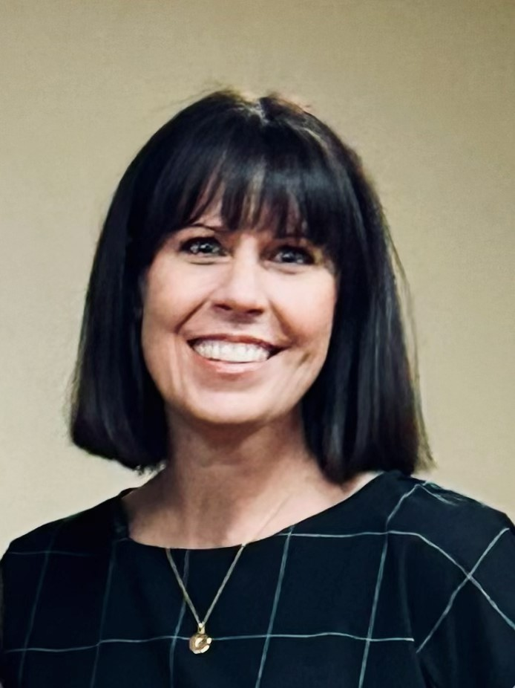
Speaker Bio

Kimberly Pendleton serves as the CPS Regional Director Assistant for Regions 1 and 2. During her 25-year tenure with the Department of Family and Protective Services Kimberly has gained experience working in the field with children and families, supervising a Conservatorship Unit, facilitating meetings with Family Group Decision Making, and overseeing FGDM, Kinship, Preparation for Adult Living , Subject Matter Experts and Family Based Safety Services in the Service Program Administrator role. After successfully transitioning case management services to regional Community Based Care partners, Kimberly entered her current role where she continues to serve as the Juvenile Justice liaison for ongoing services.

